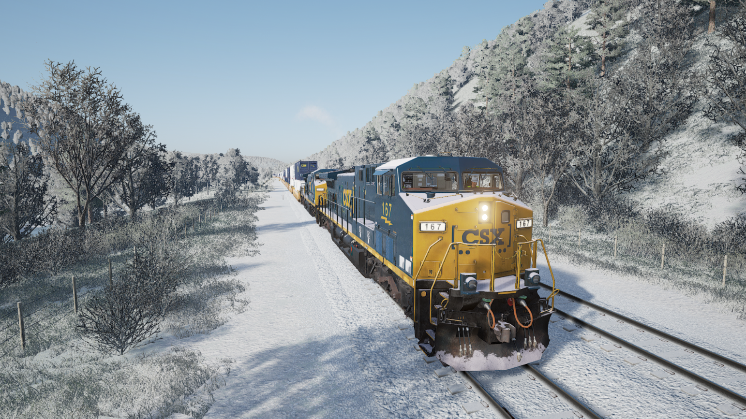

TSWTools

Toolkit for Trainsim World

Users guide

Rudolf Heijink

Version 0.1 alpha

***Copyright © 2017 Rudolf Heijink.***



***This work is licensed under the Creative Commons Attribution-NonCommercial-ShareAlike 4.0 International License. To view a copy of this license, visit http://creativecommons.org/licenses/by-nc-sa/4.0/ or send a letter to Creative Commons, PO Box 1866, Mountain View, CA 94042, USA.***

***You are free to:***

* **Share** — copy and redistribute the material in any medium or format
* **Adapt** — remix, transform, and build upon the material

The licensor cannot revoke these freedoms as long as you follow the license terms.

***Under the following terms:***

|  |  |
| --- | --- |
| http://mirrors.creativecommons.org/presskit/icons/by.large.png | **Attribution** — You must give [appropriate credit](http://creativecommons.org/licenses/by-nc-sa/4.0/), provide a link to the license, and [indicate if changes were made](http://creativecommons.org/licenses/by-nc-sa/4.0/). You may do so in any reasonable manner, but not in any way that suggests the licensor endorses you or your use. |
| http://mirrors.creativecommons.org/presskit/icons/nc-eu.large.png | **NonCommercial** — You may not use the material for [commercial purposes](http://creativecommons.org/licenses/by-nc-sa/4.0/). |
| http://mirrors.creativecommons.org/presskit/icons/sa.large.png | **ShareAlike** — If you remix, transform, or build upon the material, you must distribute your contributions under the [same license](http://creativecommons.org/licenses/by-nc-sa/4.0/) as the original. |
|  | **No additional restrictions** — You may not apply legal terms or [technological measures](http://creativecommons.org/licenses/by-nc-sa/4.0/) that legally restrict others from doing anything the license permits. |

***Notices:***

* You do not have to comply with the license for elements of the material in the public domain or where your use is permitted by an applicable [exception or limitation](http://creativecommons.org/licenses/by-nc-sa/4.0/).
* No warranties are given. The license may not give you all of the permissions necessary for your intended use. For example, other rights such as [publicity, privacy, or moral rights](http://creativecommons.org/licenses/by-nc-sa/4.0/) may limit how you use the material.

# Preface

***Introduction***

The last years I created a number of manuals and tools for DTG TrainSimulator. Mike Simpson, the author of the world famous RWTools has been an important source of inspiration to me. I never tried to copy his work, but I found some niches specifically for scenario authors that are not covered by RWTools. Mike announced he will not create such a toolkit for TSW. So I decided I could claim the TSWTools name with a lot of respect and thankfulness to Mike. I cannot but admire his perseverance in reverse engineering undocumented features without any support from DTG.

Here it is, the very first edition of TSWTools. It’s not doing much yet, but the start is there.

***Acknowledgements***

All anonymous members of the TSW community for sharing their experience and helpfulness.

The creators of [Inno setup](http://www.jrsoftware.org/) for providing a free installer.

***License agreement***

The software and this guide are licensed underthe Creative Commons Attribution-NonCommercial-ShareAlike 4.0 International License. Details are provided in the license agreement you must sign before using the software.

***Disclaimer***

This guide is provided “as is”. The author is not liable for the consequences of the use of this guide or the LuaCreator application. The contents is the sole responsibility of the author.

***Contact***

Comments are welcome at [trainsimulator@hollandhiking.nl](mailto:trainsimulator@hollandhiking.nl).

But please be aware that I cannot provide you help with you scenario creating problems. If you have any questions, please use one of the regular community forums.

***Front page image***

One of my own screenshots made at the Sandpatch route. It still has a “wow” effect on me seeing all the details.

Rudolf Heijink

Contents

Preface 3

1 Introduction 6

1.1 New in this version 6

1.1.1 Version 0.1 6

7

2 Installation 7

2.1 Installation procedure 7

3 Main screen 8

3.1 Overview 8

3.2 About dialog 9

3.3 Options Dialog 10

3.4 Unpack 11

3.5 View key bindings 11

3.6 View screenshots 12

A. Download locations 14

B. Known issues 15

Index 16

List of figures

Figure 1 TSW Tools Main Screen 8

Figure 2 About Dialog 9

Figure 3 Options dialog 10

Figure 4 Key bindings or input mappings 11

Figure 5 Screenshot viewer 12

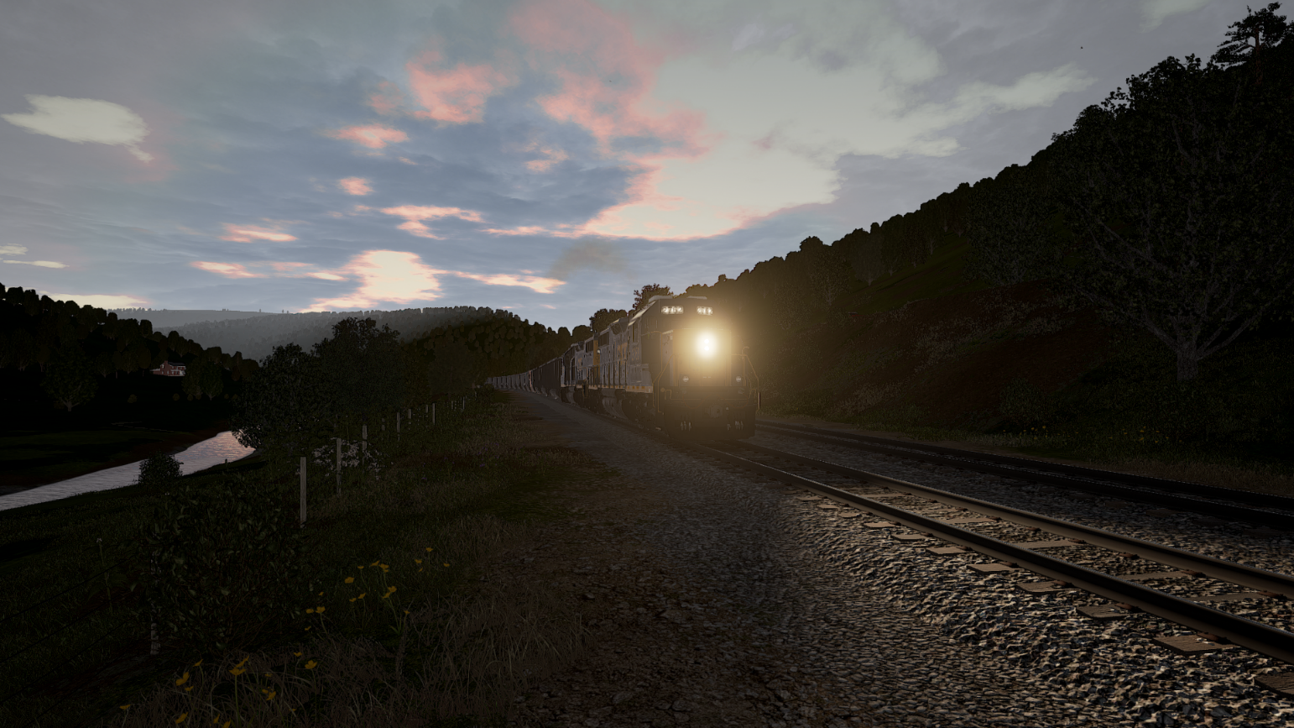

# Introduction

## New in this version

### Version 0.1

This is the first version. It does some basic stuff:

* You can easily unpack the game .pak files.
* You can view the files at the game location as well as the unpacked files
* There is a simple screenshot manager
* You can view the input mappings (but not edit them)
* You can view and edit the game settings outside the game.

# 

# Installation

## Installation procedure

The game comes with an installer. Installing it is straight forward.

It has been tested using Windows 10, but likely will work in other enviroments as well. TSW Tools is written in C# and requires the latest .NET version to run.

You need to install the Unreal game engine.

In order to read the manual, you need a pdf reader (by reading this it is clear to me you have that).

It is recommended to install a good text editor as well. Notepad++ is a good solution.

Check out [www.hollandhiking/trainsimulator](http://www.hollandhiking/trainsimulator) for download links.

# Main screen

## Overview

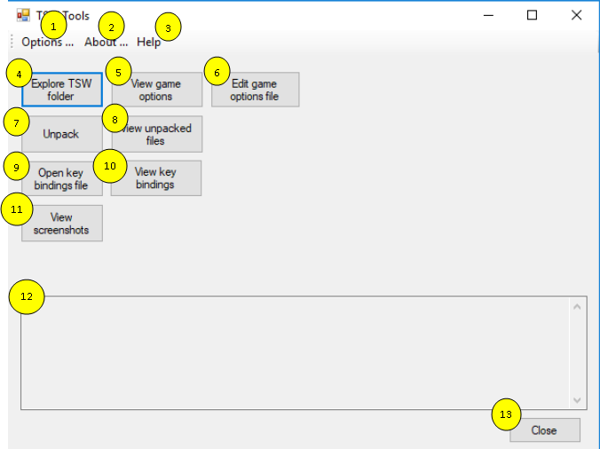In Figure 1 the TSWTools main screen is depicted. Each function will be introduced in the subsequent sections.

Figure 1 TSW Tools Main Screen

1. Options, tool options. You need to set the options before you can use TSWTools
2. About dialog
3. Opens the manual in a pdf reader
4. Explore the folder where TSW is installed, using explorer
5. View the game options in a table, you cannot yet edit them here.
6. Edit the game options file with e text editor.
7. Unpack the game .pak files using the unreal unpacker (takes a lot of time!)
8. View the unpacked files using explorer
9. Open the key bindingsfile in a text editor, editing has no effect!
10. View the key bindings in a neat table format
11. The screenshot manager
12. Message box that contains anything TSWTools likes to tell you
13. Close button, terminates TSWTools

## About dialog

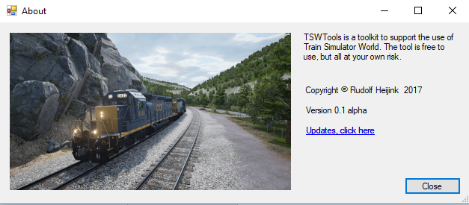The About Dialog informs you about the actual version of TSWTools. Unfortunately the update link is not yet working.

Figure 2 About Dialog

## Options Dialog

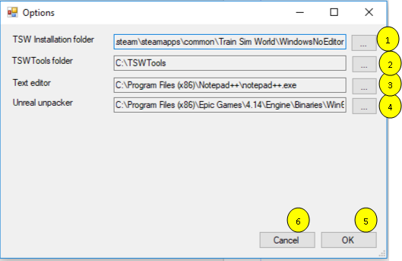Before you can use TSWTools you need to set the options. Normally you only need to do this once. Options are stored in the registry.

Figure 3 Options dialog

1. **TSW Installation folder**. Click at the three dots to open an Open File Dialog. Make sure your path ends with “WindowsNoEditor” otherwise it will not have the desired effect and some functions of TSWTools will not work.
2. **TSWTools folder** is the folder where TSWTools will install its datafiles, e.g. the unpacked game. So this folder requires a lot of space.
3. **Text editor**. Notepad is used as a default, but I recommend to choose a better option.
4. **Unreal unpacker**. Is the unpacker in the Unreal Engine. If you have the engine installed by using defaults, you probably do not need to do anything.
5. **OK button** saves your changed settings
6. **Cancel** will cancel all updates in settings

## Unpack

This function will unpack the game files. It cycles through all .pak files it can find and uses the unreal unpacker to do the job. It may take a lot of time, during which TSWTools appear to hang. Please have a lot f patience.

In future I will implement a better progress indicator or make it run as a background task. But this is a 0.1 alpha version, remember?

## View key bindings

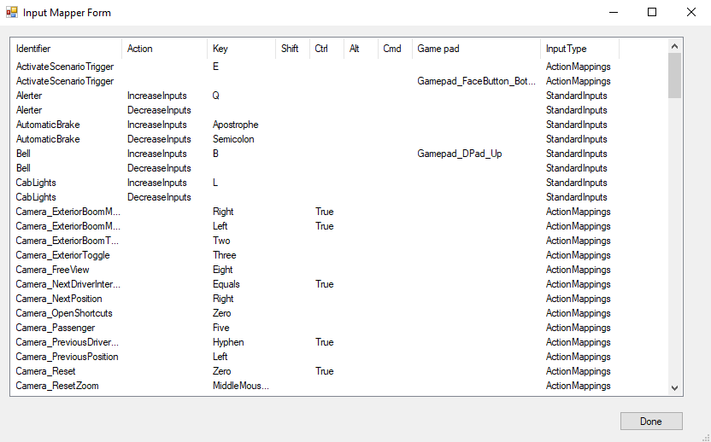

Figure 4 Key bindings or input mappings

This is not a tool doing much, but it gives you a nice overview of most input mappings. Anyway, it helped me to discover some undocumented features. The mappings are sorted alphabetically. I will see if I can add other sorting options and maybe a search function.

I

## View screenshots

TSW has essentially two screenshot

methods:

You can use the F12 key to get a screenshot including the HUD. Essentially this is the steam screenshot facility.

You can use Ctrl+F12 to get a TSW screenshot, without any HUD stuff.

Unfortunately the two types of screenshots are stored at different locations and have different size and file format.

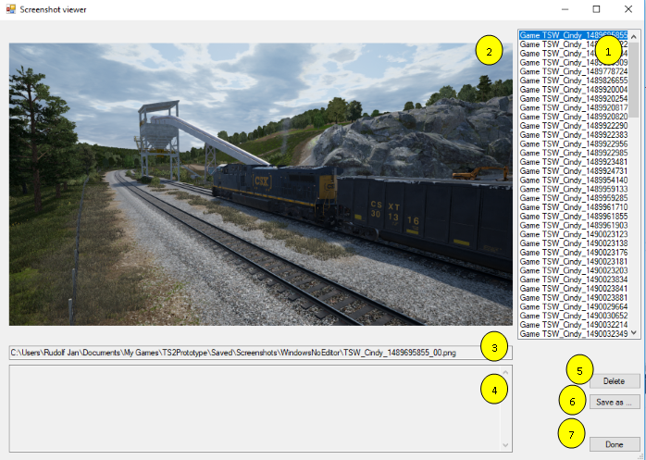Therefore TSWTools includes a screenshot viewer that brings them all together. You also can delete screenshots here or make a local copy if you like.

Figure 5 Screenshot viewer

1. The list with all screenshots found. Use the mouse or cursor keys to cycle through the list
2. Shows the actually selected screenshot
3. Shows the path to the selected screenshot
4. Space for messages from TSWTools
5. Deletes the selected screenshot. Warning: it does NOT ask for confirmation!
6. Opens a file dialog and copies the selected screenshot to the desired location, while updating the file name.
7. Closes this dialog

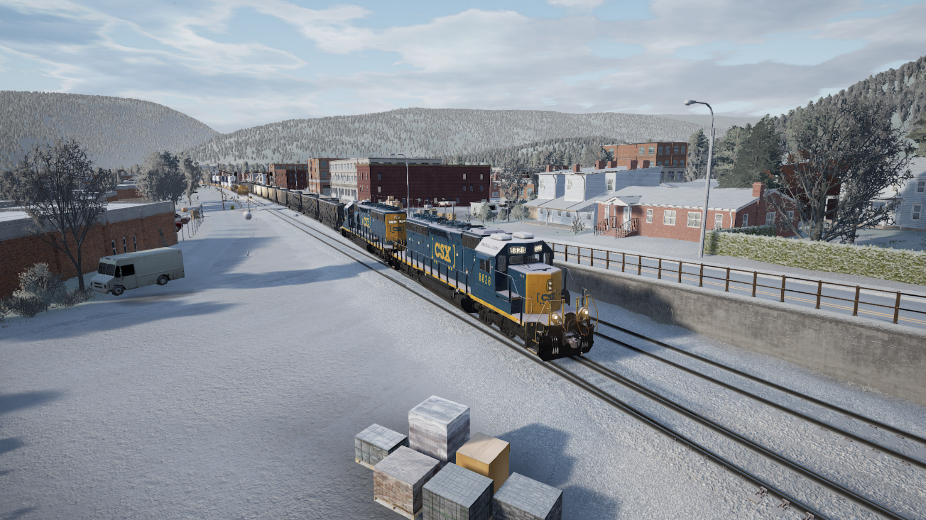

1. Download locations

All my guides and tools are available here:

|  |  |
| --- | --- |
| Site name | URL’s |
| Holland Hiking (download page for all tools and guides) | <http://www.hollandhiking.nl/trainsimulator/> |

At this site you also will find links to all other tools and manuals mentioned in my guides.

1. Known issues

There are some issues I am aware of, but not yet solved. These are listed here.

|  |  |  |
| --- | --- | --- |
| Issue nr | Description | Priority |
| 1 | Long waiting time for unpack | High |
| 2 | Screenshot saver does not remember last save location | Low |
|  |  |  |
|  |  |  |

Index

About dialog 8

About Dialog 9

download link 12

download links 7

game options 8

input mapper 8

input mapping 11

Installation 6

key binding 8, 11

main screen 8

manual 7, 8

New features 6

Notepad++ 7

options 8, 10

screenshot 12

text editor 7, 10

TSW folder 8, 10

TSWTools folder 10

unpack 11

Unreal game engine 7

Unreal unpacker 8, 10